CSC 4640 Microcontroller Programming

Class Project #1

Temperature and Humidity Monitor

Sam and Mason

For this project we were tasked with building a temperature and humidity monitoring system. For this we were using the AHT-20 I2C temperature sensor, the Arduino Uno Rev3, and the Adatafruit FeatherWing OLED 128x64 screen. This project works with the AHT-20 getting the data from its sensor, and then that data and signal is sent directly to the OLED screen.

For specifications on this project, we have an OLED screen that has a display of 128x64 (Pixels) and is used to display information. As for our temperature sensor its specs are as follows: +- 2% relative humidity, and a +-0.3 degrees Celsius while relative humidity is between 20 and 80%, the temperature range is then 20-60 degrees Celsius.

Bill of Materials:

* Adatafruit AHT-20 temperature and humidity sensor: $4.50 <https://www.adafruit.com/product/4566>
* Adatafruit FeatherWing OLED – 128x64: $14.95

<https://www.adafruit.com/product/4650>

* Arduino Uno Rev3: $27.60

<https://store-usa.arduino.cc/products/arduino-uno-rev3?selectedStore=us>

* Miscellaneous wiring (jumper cables etc.): approx. $0.50 – $1.00

Block Diagram for the Device:

Circuit Schematic:

Source Code:

1. /**************************************************************************
2. Tests the getTemperature and getHumidity functions of the aht20 library
3. **************************************************************************/
4. #include <SPI.h>
5. #include <Wire.h>
6. #include <Adafruit_GFX.h>
7. #include <Adafruit_SH110X.h>
8. #include <Wire.h>
9. #include <AHT20.h>
10. AHT20 aht20;
11. Adafruit_SH1107 display = Adafruit_SH1107(64, 128, &Wire);
12. void setup() {
13. Serial.begin(115200);
14. Serial.println("Humidity AHT20 examples");
15. Wire.begin();  //Join I2C bus
16. //Check if the AHT20 will acknowledge
17. if (aht20.begin() == false) {
18. Serial.println("AHT20 not detected. Please check wiring. Freezing.");
19. while (1)
20. ;
21. }
22. Serial.println("AHT20 acknowledged.");
23. Serial.println("128x64 OLED FeatherWing test");
24. delay(250);                 // wait for the OLED to power up
25. display.begin(0x3C, true);  // Address 0x3C default
26. Serial.println("OLED begun");
27. // Show image buffer on the display hardware.
28. // Since the buffer is intialized with an Adafruit splashscreen
29. // internally, this will display the splashscreen.
30. display.display();
31. delay(1000);
32. // Clear the buffer.
33. display.clearDisplay();
34. display.display();
35. display.setRotation(1);
36. // text display tests
37. display.setTextSize(1);
38. display.setTextColor(SH110X_WHITE);
39. display.setCursor(0, 0);
40. display.print("Connecting to AHT-20':");
41. display.println("connected!");
42. display.println("Getting temp...");
43. display.println("Getting humidity...");
44. display.display();  // actually display all of the above
45. }
46. void loop() {
48. if (aht20.available() == true) {
49. //Get the new temperature and humidity value
50. float temperature = aht20.getTemperature();
51. float humidity = aht20.getHumidity();
52. Serial.print("Temperature: ");
53. Serial.print(temperature, 2);
54. Serial.print(" C\t");
55. Serial.print("Humidity: ");
56. Serial.print(humidity, 2);
57. Serial.print("% RH");
58. Serial.println();
59. display.clearDisplay();
60. display.setCursor(0, 0);
61. display.print("\n");
62. display.print("\n");
63. display.print("Temperature: ");
64. display.print(int(temperature));
65. display.print("C");
66. display.print("\n");
67. display.print("\n");
68. display.println("Relative");
69. display.print("Humidity: ");
70. display.print(int(humidity));
71. display.print("%");
72. display.print("\n");
73. yield();
74. display.display();
75. }
76. //The AHT20 can respond with a reading every ~50ms. However, increased read time can cause the IC to heat around 1.0C above ambient.
77. //The datasheet recommends reading every 2 seconds.
78. delay(2000);
79. }

3d Models:

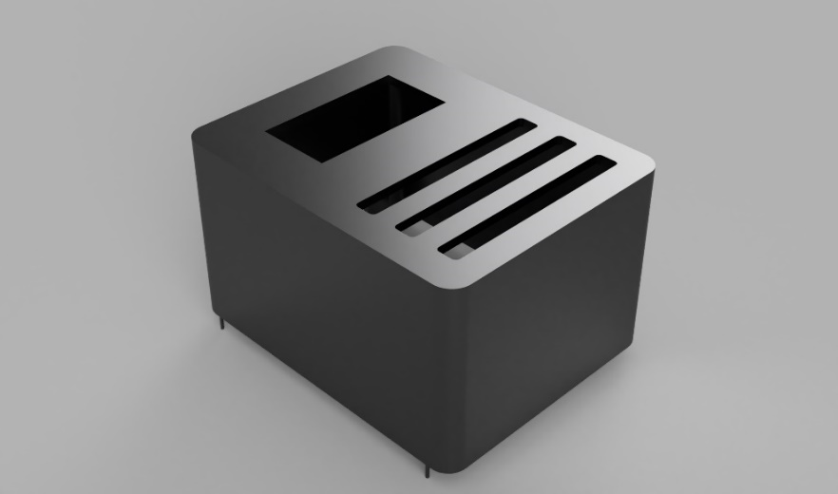

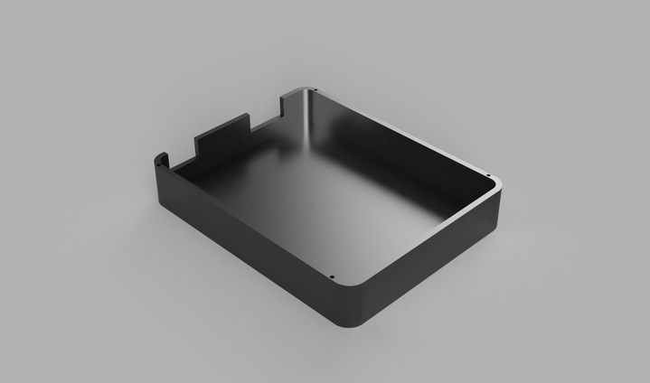

8. Pictures and YouTube link of the device in action:

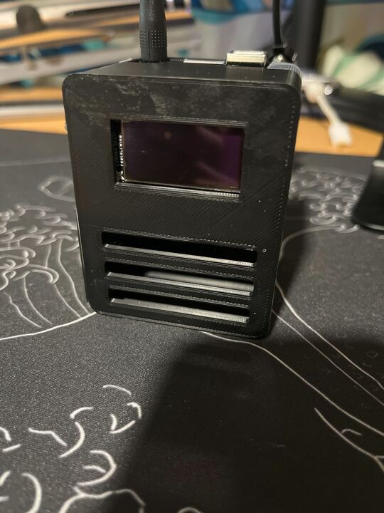

YouTube Link:

<https://youtube.com/shorts/RZdDvgY6D6E>

* Video Note: In the video you can see that the device reads 24C which when converted to Fahrenheit is about 75.2 which is different to the 84 read by the apple app. This difference is due to the app calculating temperature based on the outdoor temperature while the AHT-20 sensor is sensing the indoor temperature of the Greek suites which is air conditioned and usually sits at about 70-80 degrees Fahrenheit or 21 – 26 Celsius. We were unable to test the device outdoors due to rain, which would not be good for the device which is not water resistant.
* The battery life of the device (from a single 9V batter) was about 48 hours.

GitHub link for the source code:

<https://github.com/SamLewis347/MIcrocontroller-Programming-AHT20-to-Featherwing-OLED>

Conclusions:

This project gave a large amount of good information that will be useful for the future. We learned the basics of I2C and connecting devices to Arduino using this standard. We learned about interfacing data given from a sensor and displaying that data through another device (not just in the serial monitor), and how to further use 3D modeling as well as rapid prototyping to create parts to create the device that was made for this project. This knowledge will continue to be useful in future projects as many of the fundamentals we learned in the process of making this device (3D modelling, using displays, interfacing displays and components, etc.) will be skills that we need for future and more advanced applications.